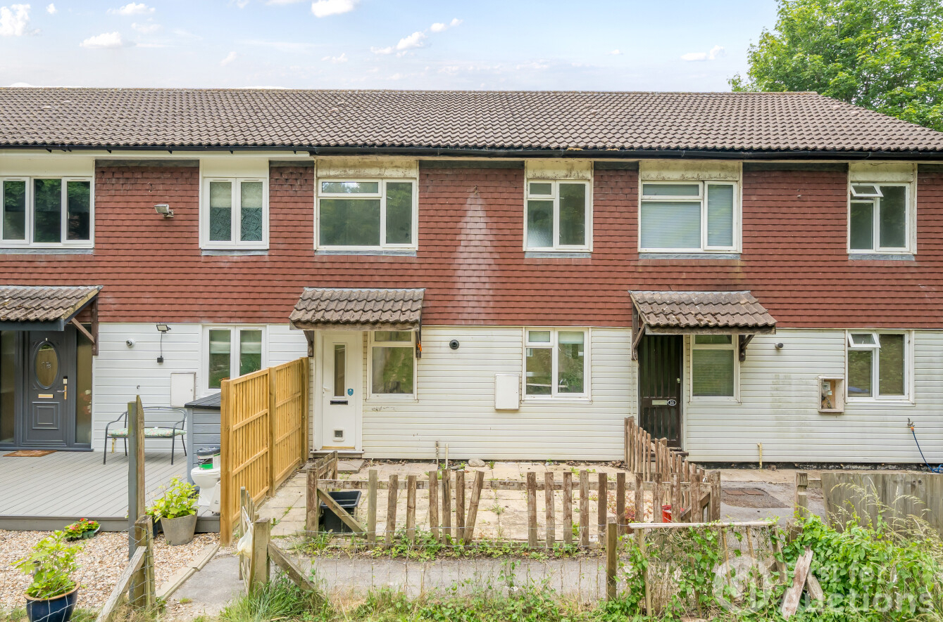

Guide Price
£90,000
Freehold

A vacant three bedroom terraced house requiring refurbishment, located in Tidworth. Situated within easy reach of local schools, shops, and amenities, the property also benefits from transport links via the A303, providing convenient access to Salisbury, Andover, and surrounding towns.

It is understood that this property is of concrete construction. Prospective buyers seeking mortgage finance are advised to consult their lender before placing a bid.
11 Forest Drive, Tidworth, Wiltshire, SP9 7PF

Auction
To be sold by online auction (unconditional) on Thursday 31st July 2025 with a 6 WEEK COMPLETION, bidding will open at 10.00.

To view
Viewings will be conducted prior to the auction, please visit our website to book an appointment at firstforauctions.co.uk

Registration
All bidders/potential buyers are required to register ahead of the auction date to be able to bid/buy, please visit our website to setup an online auction account.

Tenure
Freehold with vacant possession

EPC rating
D

Council tax band
A - Wiltshire

Legal pack
For each lot there are Special Conditions of Sale and other documentation provided by the vendor's solicitors. If you wish to receive the Legal Pack, you will be able to register for this via the link on our website. You will receive notification by email once the Legal Pack is received from the solicitor. The documents may not tell you everything you need to know about the property and you are required to complete your own due diligence before bidding.

Guide prices
Guide Prices are provided as an indication of each seller's minimum expectation. They are not necessarily figures which a lot will sell for and may change at any time prior to the auction. Each lot will be offered subject to a Reserve, (a figure below which the Auctioneer cannot sell the lot during the auction) which we expect will be set within the Guide Range, or no more than 10% above a single figure Guide Price.

Additional fees
A buyers charge of £1,500 including VAT is payable on each lot that you buy, in addition to the sale price. Please be aware there may be other additional fees, including disbursements contained in the legal pack payable on completion. Please ensure that you check the legal pack for each lot that you are interested in, prior to bidding.

Deposit
If you are the highest bidder when the auction ends, contracts are exchanged between you and the seller. Both parties are legally bound to complete the transaction as per the special conditions in the legal pack. Your card will be automatically debited for the bidder security amount of £6,000 and we'll require the remaining balance for a 10% non-refundable deposit. We will contact you after the auction has finished to make these arrangements.

Pre-auction offers
These must be made in writing and will only be considered if the Legal Pack has been inspected and proof of funding has been supplied to the auctioneers. Pre-auction offers are only considered on an auction basis in accordance with the “Terms & Conditions - Unconditional Auction".

Mortgage finance
We advise all bidders who require a mortgage to confirm with their Financial Advisor as to whether or not the lot you are interested in would be suitable security to borrow finance against, prior to bidding. If you need to arrange a mortgage it is important that you obtain an offer from your lender before the day of the auction. Most building societies and banks will instruct a surveyor to prepare a valuation report before making a mortgage offer.



